[Insert lab title] Safety Report

[Insert title of testing. e.g., Tensile Testing of Titanium Dogbone Samples]

Date: | [DD/MM/YYYY]
Student & SU nr: | [insert student name + surname, student nr.]
Student contact nr: | [insert student cell number]
Supervisor: | [insert supervisor name + surname]
Lab engineer: | [insert lab engineer responsible for lab]
Head of safety: | Mr Cobus Zietsman [unless otherwise]

Emergency Contacts:

Contact: | Room nr. | Work nr. | Cell nr.
[insert lab engineer] | [insert room nr.] | - | [insert cell number]
Mr C. Zietsman [unless other] | M212 | 021 808 4275 | -
Campus Security | - | 021 808 2333 | WhatsApp:  082 808 233
Fire Brigade | - | 021 808 8888 | -
Ambulance | - | 021 883 3444 | -

Signatures:

Student:
([insert name])
Supervisor:
([insert name])
Lab Engineer:
([insert name])
Head of Safety:
(C Zietsman) [unless other]

Pressure vessels or pipes (check relevant box):
☐ No pressure vessels or pipes with pressure in excess of 50kPa are involved in this project.
☐ Pressure vessels or pipes in excess of 50kPa are involved – additional signature and report required (refer to Safety Report Guidelines on SUNLearn).

Hot work / working at heights / confined entry / excavation (check relevant box):
☐ No hot work / working heights / confined entry / excavation work involved in this project.
☐ Hot work / working heights / confined entry / excavation work (underline relevant work type(s)) involved in this project – additional signature and report required (refer to Safety Report Guidelines on SUNLearn).
[Take note: This document must be prepared in accordance with the Safety Report Guidelines available on SUNLearn. Specifically, Appendix A of the Safety Report Guidelines gives examples of a risk analysis table in an example safety report as applicable to tensile testing in the Structures lab. Contact relevant lab engineers for similar tables that apply specifically to other labs. NB: Remove any yellow highlighted text (such as this paragraph) and replace it with prompted information where applicable. There should be NO yellow text in your final submitted safety report.]

Overview of Testing

Type of test and standard (if applicable):

Test type | [Eg. Room temperature tensile testing with DIC]
Standard(s) | [Eg. ASTM E8M, iDIC good practices guide]

Equipment to be used:

Equipment type | Make & model | Measurement range (if applicable) | Resolution (if applicable)
[Eg. Tensile tester] | [Eg. MTS criterion model 44] | [Eg. maximum travel/crosshead speed] | [Eg. in terms of crosshead position/speed]
[Eg. digital image correlation system: camera] | [Eg. LaVision E-lite system] | [Eg. Maximum frame rate of 2 Hz] | -

Sample geometry:

Sample Cross-Section* | Expected Max. Stress* | Expected Max Load | Number of Samples

[*This would not apply to tests such as three-point bending tests. In this case, maximum midpoint deflection and expected load corresponding to maximum surface stress should be considered]

Detailed Experimental Procedure

[The purpose of this section is to clearly communicate the purpose for equipment use and list the steps necessary to prepare the equipment for testing. It should include a short introduction to outline the purpose of the report. It should also include descriptions of the tests that will be performed including the entire initial setup and takedown procedure for using the equipment. It is not necessary to include all the operating procedures of the actual testing as that will be discussed in your project reports, but the critical steps with the associated risks should be clearly stated. This includes a discussion of sample geometry, testing standard, etc.]

Warning Symbols

[Please indicate the warning symbols(s) applicable to your setup. Examples are given below. Additional symbol examples can be found here]
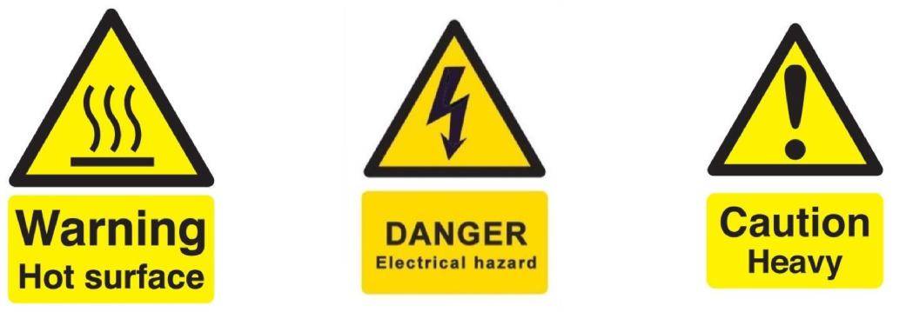

(a) Hot surface (b) Electrical hazard (c) Heavy object

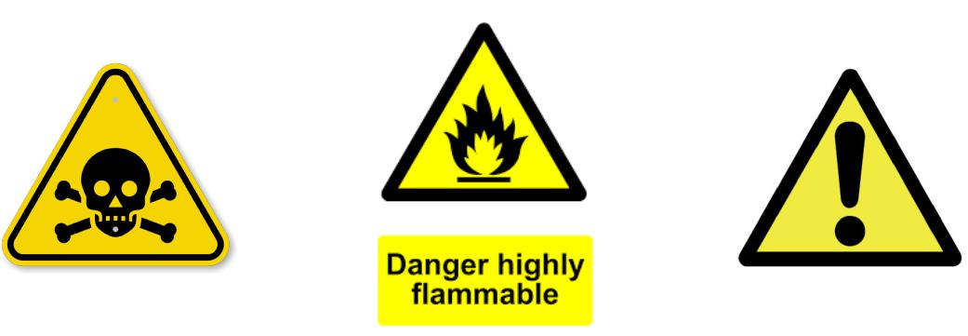

(d) Poisonous substance (f) General warning

(e) Flammable substance

Figure 1: Applicable warning/hazard symbols

General Laboratory Safety

The following general laboratory safety instructions are applicable:
- No afterhours testing may be performed without the necessary permissions.
- Full supervised training is required before testing may be undertaken. Permission to proceed with unsupervised testing should be signed off by the lab engineer.
- Closed shoes must be worn at all times.
- Emergency equipment must be located and easily accessible.
- Students may not work alone in the laboratory.
- Emergency exits must be known. The nearest exits applicable to the setup are provided in Appendix A of this document [highlight on appropriate map selected and cropped from Appendix C of the Safety Report Guidelines]
- Loose clothing may not be worn. Loose hair must be tied up.
- Good housekeeping practices should be maintained during testing. The lab should be completely clean, including all equipment stored away, after testing. Refer to the General Housekeeping section for particulars regarding practices to be followed for this specific setup.
- No food or drink is permitted in the laboratory.
- Safety report must be visible and accessible during testing.
- No equipment or test may be left unattended.

Anticipated Interactions with other Laboratory Users

[Describe any possible interactions with other laboratory users. For instance, other experimental setups that will be installed and/or operational in proximity to your own setup. Interactions between your setup and other lab users should be minimised as far as possible.]

General Housekeeping

[List specific steps taken for housekeeping as related to your particular setup. Example: returning equipment to appropriate storage and cleaning up the workspace.]

Fire Safety

[Summarise any fire safety hazards related to your project as well as mitigating measures. Circle on the appropriate map on Appendix A of this template (or similar appropriate map from Appendix C of the Safety Report Guidelines) the locations of nearest exits and fire extinguishers should this be necessary.]

Activity Based Risk Assessment

[Common examples are given in the safety report example in the Safety Report Guidelines on SUNLearn. You are responsible for adding relevant ones from the example list and including other risks unique to your own project.]

Activity | Risk | Risk Type* (P/E) | Mitigating Steps | Classification of Risk Severity
 |  |  |  | [refer to Table 1 in Safety Report Guidelines]
*P – personal, E - equipment

Disciplinary Actions
Failure to comply with any of the aforementioned safety regulations or procedures will result in disciplinary action. Students will be issued an initial warning: after three warnings, the lab access is revoked for a month.

Appendix A: Emergency Evacuation Plans [eg: Structures lab and surrounding laboratories]

[Circle applicable exits and fire extinguisher locations]

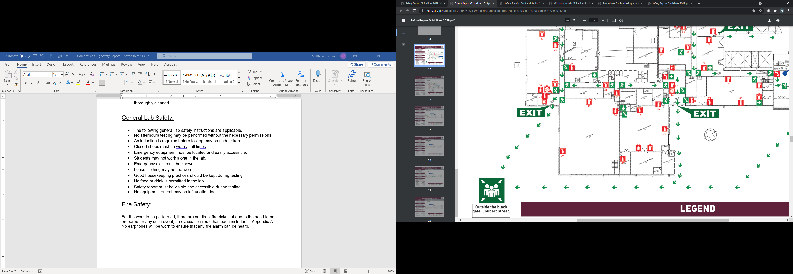

Written permission from supervisor and approved by the chief safety officer. Attach proof of this permission to this document and note here the times and conditions of the arrangement.

